Manila Water Company
FUNCTIONAL SPECIFICATION – FORM
DID_L2C_6



Customer NameDocument Title





Contents
1.1 Document Log 4
1.2 Integration, Document Reference 4
2 Functional Description 4
2.1 Assumptions 5
2.2 Processing Type 5
2.3 Output Type 5
2.4 Functional Design 5
2.5 Security / Authorization Requirements 5
2.5.1 Definition 5
2.5.2 Defined Fields 5
2.5.3 Procedure 5
2.6 Process Flow Diagram 5
2.7 SAP Transaction 5
2.8 Form Layout 5
2.9 Printer Requirements 6
2.10 Legal Requirements 6
2.11 Form Fields 6
2.11.1 Main Heading 6
2.11.2 Sub Heading 6
2.11.3 Totaling 6
2.11.4 Sorting 7
2.11.5 Page Breaks 7
2.11.6 Stationery 7
2.11.7 Logo(s) 7
2.12 Bar Coding Requirements 7
2.13 Email Requirements 7
2.14 Existing Sample Forms 7
3 Assumptions in Functional Design 7
4 Open Issues in Functional Design 7
5 Business Test Conditions 8
6 Related Documentation 8
Document Organization
This section provides details about this document, previous version(s) of this document and the document(s) referred.

Document Log
Following table mentions the version changes and the processer(s):
Version | Status | Date | Version Created by (Name/E-Mail/Company) | Role | Comments
V1 | Draft | February 28, 2025 | Venkata Popuri  Venkata.popuri@diligentglobal.com | Author | Initial Version
 | Ready for Review | March 3, 2025 | Roopali Sharma  roopali.sharma02@sap.com  Mohanrangan  Mohanrangan.rangarajan@sap.com | Reviewer | Functional & Technical Review

Integration, Document Reference

NA

Functional Description
This document provides detailed functional requirements for developing An Output Form for Credit Note in SAP. The purpose of this form is to meet specific business requirements that are not fulfilled by the standard SAP forms.
- Company Logo (Header section).
- Header Information: Company Address (this is the MWC Entity which is involved in the sales & Billing) with VAT Registration & TIN below the address
- Header Information: Print as “INVOICE with Billing Document Number what contains the Statutory Number given by the Government.
- Details in body section: Customer Information contains
  - Date: Date on which Credit Memo Billing is done
  - Contract Account Number: Customer Number
  - Payer/Business Name: This is the Payee Name of the Partner Functions
  - Address: Address of the Business Partner according to Address Data of the Partner.
  - TIN: TIN details maintained in Business Partner
  - SC, PWD or Gov't ID No. / Signature
- Details Section Contains:
  - Invoice Date: Date on which Credit Memo is Created
  - Invoice Number: Invoice Number or Credit Memo Number
  - Description: Description of Credit Memo which will be pulled from Billing Document Texts maintained and against that total Net Value of the Credit Memo will be populated.
  - VAT: VAT % Applicable this includes VAT, Government Taxes, Applicable Tax percentage
  - Total : This is the Net Value plus VAT Amount
- Breakdown of Sales
  - VATable Sales: Net Value of the Credit note
  - VAT-Exemption Sales: Usually ‘0’ Rated Sales
  - Zero rated Sales: No VAT it is ‘0’ Rated Sales
  - Government Taxes: Applicable Government Taxes, usually they will be small percentages.
  - In the Amount we have VATable Sales i.e., Net value in the Credit note and VAT, Government Taxes or any Applicable Taxes.
- Footer Information: Received by, Issues by with Printed Name, Date and Signature, Acknowledgement details.

Assumptions
In the process of completing the Credit memo form design, several assumptions have been made to ensure that the form meets user needs and integrates effectively with Master, Transactional and Organizational Data with existing system(s). These assumptions are:
- Credit Memo Output is the final output document sent to the BP/Customer through email, It is assumed that users do not require any manual intervention while Sending the output to the Customer this includes Company code Data, BP/Master data like BP/Customer Name, VAT & TIN, Address and Transactional Data like Net Price, VAT, Government Taxes if Applicable (it can be either VAT or Government Taxes but not both), MWC Company Name which is issuing the Billing Document.
- The design assumes that the Credit memo will be in line with Philippines Tax norms and integrates with the Philippines TAX.
- It is assumed that there are robust data validation mechanisms to prevent errors during data entry. This includes checks for mandatory fields, format validations (e.g., date formats), and logical checks (e.g., VAT & Government Tax Conditions and Values are correct and diligently maintained in Pricing Condition Records). Texts to populate the Tax’s in Credit Memo are correctly maintained so that right Text gets printed in the Credit Memo Output related to description of the Service rendered (Items will not be populated in the Credit Memo Output Instead Billing Order Text describing the Service will be pulled into the Credit Memo)

Processing Type
Real Time Processing: This refers to immediate processing where Billing Clerk (as per Fiori App Role and can be the Authority who processes Billing as per MWC) Processes the Credit Memo takes place.

Output Type
New Output Management: SAP (S/4HANA), there is an enhanced output management framework that uses BRF+ (Business Rule Framework plus) for more complex scenarios. Here we can define rules for determining when outputs should be generated and what formats they should take.

Functional Design
As soon as Billing Document is Saved the Tax Invoice output will be generated based on the Values pulled from Billing Document, Master and Organizational Data what is a crucial document used in Sales processes across MWC Legal entities. It is a Legal Document sent by MWC Entities to the Customer/Business Partner which includes, Service/Item Description as per the Text provided in the Billing Document and agreed prices for products or services and Tax applicable.
Components of the Tax Invoice Form
- Header Information:
- Company Logo on the facing Left corner of the Invoice.
- Company Address, this is the MWC Entity which is involved in the sales & Billing with VAT Registration & TIN below the address. This will be pulled from the specific Company Details as we have 20 Legal entities.
- “INVOICE” as a Header Print as standard for all the Non-Trade Invoices with unique Invoice Number provided by Philippines Tax authorities.
- Customer Information: this section contains
  - Date: Date on which Credit memo is created
  - Contract Account Number: Customer Number
  - Payer Business Name: this will be extracted from Payer or Business Name
  - Address: Address of Customer as per BP Record
  - TIN Number: TAX Identification Number pulled from BP
  - SC, PWD or Gov't ID No. / Signature: This is pulled from BP Identification
- Details: This Section Contains
  - Invoice Date: Date on which Credit Memo is Created
  - Invoice Number: Billing/Invoice Number
  - Description: This Text is pulled from the Billing document Texts
  - Amount: This Contains Total Net Value of the Credit memo
  - VAT: VAT %
  - Total Debit/Credit: Total Value in the Credit Memo
- Breakdown of Sales Contains
  - VATable Sales: VAT Applicable Sales
  - VAT Exempt Sales: VAT Exempted Sales
  - Zero Rated Sales: ‘0’ Rated Sales
  - VAT: VAT or Applicable Government Taxes

Apposite of these will be the Amount plus Taxes under the head Amount.

Security / Authorization Requirements

NA

Definition

The SAP Credit Memo is a Legal Document that is sent to the Business Partners/Customers for the amount to be paid. This is an output after the Billing is done for the services Rendered after Sales & Delivery. This form captures essential information such as Business Partner details, item description, quantities (If Applicable), pricing, VAT Details/Government Taxes, terms of payment. By utilizing this standardized form, organizations can ensure compliance with internal policies and external regulations while enhancing communication with customers through various medium like Email, Fax, Print.
Credit Memo Form Layout

Defined Fields

Table Name | Field Name | Format | Default Value | Table Value/Radio Button | Select Option/Parameter | Mandatory or Optional
VBRK | VBELN | Numeric | - | Table Value | Parameter | Mandatory

Create a Custom Transaction & Screen for getting both emails & Print Outputs as below:
Selection Criteria:

Billing Document – VBRK-VBELN (Mandatory)

Printing Mode: (Radio buttons)
Print

Email

Print Type

Initial

Re-Print

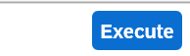

The Input field will be Billing Document Number this will bring in the Billing Document Type, Output Type, and the form relevant to the process. The details of logic are given below as to what details need to be printed on the Tax Invoice/Credit Invoice.

Tabs – Print and Email
PRINT - “Types of Execution:” Heading-hardcoded
1st Radio Button for “Initial Print” (Optional)
2nd RADIO BUTTON for “Re-Print” (Optional)
Email “Types of Execution” Heading- Hardcode
1st Radio Button for “Initial Email” (optional)
2nd Radio Button for “Re-Issue Email” (optional)

Detailed logic to extract the required data for the development of Tax Invoice Form:

- Header Details & Logic: -

MWC Logo will be the same across the Legal entities, MWC Address will be dynamic and should be extracted from the Company Address from the Organization structure with respect to the MWC entity/Company Code in context.

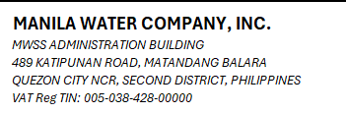
Address Extraction:
Company Code M001, Manila Water Company, INC.
MWSS Administration Building
489 Katipunan Road, Matandang Balara
Quezon City NCR, Second District, Philippines.
VAT Reg TIN:005-038-428-00000

Company Code Address Logic:

Pass the company code (BUKRS) in table T001 to get the address
(ADRNR) then pass the ADRNR-ADDRNUMBER in Table ADRC to get
the name (NAME1), Street (STREET), street 2(STR_SUPPL1), street 3
(STR_SUPPL3), Street 4 (STR_SUPPL4), city (CITY1),
postal code (POST_CODE1), region (REGION), country (COUNTRY),3.
district (CITY2).

Credit Memo– Standard Print will not change across all MWC Entities, this can be static in the Printout for all the entities.

Credit Memo No. No. H001YYMM-0000000001 is pulled from the Reference Number in the Billing Document. The Reference Document field of the Billing Document VBRK-XBLNR this is the ODN, this needs to be pulled and placed under Credit Memo.

- Customer Information:

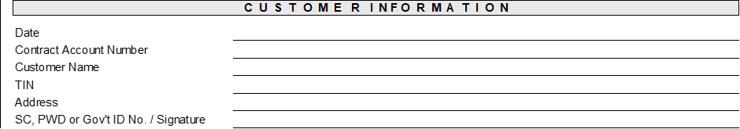

Date: Date on which the Credit Memo is created VBRK-FKDAT

Contract Account Number: Pass Billing document Number VBELN in Table VBPA-VBELN, Pick Partner function RE Bill to Party where VBPA-PARVW = RE (Bill to Party), Pass the value in VBPA-PARVW = RE, Pick Customer Number against RE in PARVW.

Customer Name: Pass Billing document Number VBELN in Table VBPA-VBELN, Pick Partner function RE Bill to Party where VBPA-PARVW = RE (Bill to Party), Pass the value in VBPA-PARVW = RE, Pick Customer Number against RE in PARVW, Copy address Number from VBPA-ADRNR and pass the same in ADRC Table ADRC-DDRNUMBER And Pick ADRC- NAME1 for Customer name.

TIN: Pass Billing document Number VBELN in Table VBPA-VBELN, Pick Partner function where VBPA-PARVW = WE, Pass the value in Table DFKKBPTAXNUM-PARTNER to pick the Tax number, From Table DFKKBPTAXNUM pick DFKKBPTAXNUM-TAXTYPE, Based on TAXTYPE = “PH1 if “PH1” is not available then pull the value of “PH3”, DFKKBPTAXNUM-TAXNUM and DFKKBPTAXNUM- TAXNUMXL.

Address of the Customer: Pass Billing document Number VBRK-VBELN in Table VBPA-VBELN, Pick Partner function BP where VBPA-PARVW = BP, Pick Address Number VBPA-ADRNR and pass the address number into ADRC-ADDRNUMBER and get Customer Address details ADRC-NAME1,ADRC-NAME2, ADRC-STREET,ADRC- HOUSE_NUM1,ADRC- POST_CODE1, ADRC- CITY1,ADRC- COUNTRY,ADRC-REGION.

SC, PWD or Gov't ID No. / Signature: Pass Billing document Number VBELN in Table VBPA-VBELN, Pick Partner function where VBPA-PARVW = WE, Pass the value in Table DFKKBPTAXNUM-PARTNER to pick the Tax number, From Table DFKKBPTAXNUM pick DFKKBPTAXNUM-TAXTYPE, Based on TAXTYPE = “PH1 if “PH1” is not available then pull the value of “PH3”, DFKKBPTAXNUM-TAXNUM and DFKKBPTAXNUM- TAXNUMXL.

Note: If Customer TIN Details are given then there will be no Government ID meaning “SC, PWD or Gov't ID No. / Signature” Details.

- Details

Invoice Date: Date on which the Credit Memo is created VBRK-FKDAT

Invoice Number: VBRK-VBELN

Description: Credit Memo Purpose of creation is a Text field in Billing/Credit memo Document, this will be pulled from Text maintained in the Billing Document Header Text, this has to be retrieved and printed here for this, use VBRK-VBELN – Billing Document, this will be the Text Name i.e., VBELN, Text ID – Z003 – Billing Period, STXH - STXD text file header Table, use Transaction SE37 & enter Function Module READ_TEXT to retrieve the corresponding Text place it under Description as above.

Please pull this “Billing Output Text” into the Billing Document Description,

Please also have a hard Coded line for VAT, if VAT @ 12% is Applicable please use the below Logic and pull the Value on to the Amounts column, AVT 12% & Government TAX 2% only will appear below the Net Amount. The below will only be the description that is pulled for applicable taxes where applicable.

VAT Exempt Sales
Zero-Rated Sales
VAT @ 12%
Government Taxes

Amount of corresponding Taxes will appear in Amount column

% VAT will appear in front of each VAT line item where applicable.

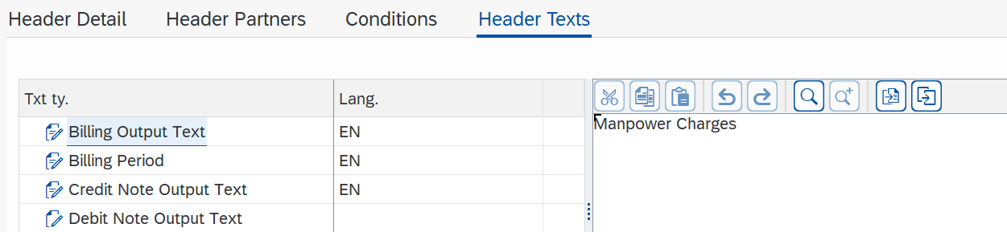

Amount: Use VBRK-VBELN Billing Document Number, pickup VBRK-NETWR – Net Value.

Tax @ 12%: Value Added Tax – 12% - pass VBRP-VBELN – Billing Document number, pickup VBRP-MWSKZ – Tax Code and pass it in T007S – Tax Code Names T007S-MWSKZ and pickup T007S-TEXT1 and place under Amount below Net Value.

Total: Use VBRK-VBELN Billing Document Number, pickup VBRK-NETWR – Net Value & VBRK- MWSBK Tax Amount, add both to arrive at Total Sales and have the Amount against Total.
- Breakdown of Sales

Note: All the above Text will be hard coded example:

VATable Sales - VBRK-NETWR

VAT Exempt Sales
Zero-Rated Sales
VAT @ 12%
Government Taxes

Amount of corresponding Taxes will appear in Amount column

% VAT will appear in front of each VAT line item where applicable.

VATable Sales: Use VBRK-VBELN Billing Document Number, pickup VBRK-NETWR – Net Value

VAT Exempt Sales: Value Added Tax – 0% - pass VBRK-VBELN – Billing Document number, pickup VBRP- J_1BTXSDC – Tax Code and check with maintenance Table like TVARVC where the Tax Code and corresponding Values will be Maintained as below.

Zero rated Sales: Value Added Tax – 0% - pass VBRP-VBELN – Billing Document number pickup VBRP- J_1BTXSDC – Tax Code and check with maintenance Table like TVARVC where the Tax Code and corresponding Values will be Maintained as below:

VAT @ 12 %: This will be displayed below the Vatable sale in Details Screen. Logic is Value Added Tax – 12% - pass VBRP-VBELN – Billing Document number, pickup VBRP- J_1BTXSDC – Tax Code and check with maintenance Table like TVARVC where the Tax Code and corresponding Values will be Maintained as below:

Tax Code | Description
O1 | VAT Exempt Sales
O2 | Zero-Rated Sales
O3 | VAT Sales 12%
O4 | VAT NRFC - Government Taxes 2%
O5 | VAT & NFT - Lambunao

Government Taxes the Taxable value is 2%: pass VBRK-VBELN – Billing Document number, pickup VBRP- J_1BTXSDC – Tax Code and check with maintenance Table like TVARVC where the Tax Code and corresponding Values will be Maintained as above.

Total: Use VBRK-VBELN Billing Document Number, pickup VBRK-NETWR – Net Value & VBRK- MWSBK Tax Amount, add both to arrive at Total Sales and have the Amount against Total Sales.

- Footer Details

  - Received By under this Printed Name, Date and Signature leave it Blank.

  - Issued By under this Printed Name, Date and Signature, the space should be filled by the MWC Company Name, Pass the company code (BUKRS) in table T001 to get the address (ADRNR) then pass the ADRNR-ADDRNUMBER in Table ADRC to get
the name1 (NAME1), Name 2 (NAME2) of MWC Entity.
  - Acknowledgement Certificate Number Logic will be Maintenance table ZDT_R2R_PERMITNO. The Logic is already given in the Table. Please check the same below.
Series Range is The Credit Invoice Number should be pulled from the Reference Document field of the Billing Document VBRK-XBLNR this is the ODN.

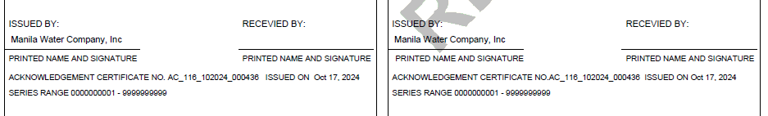

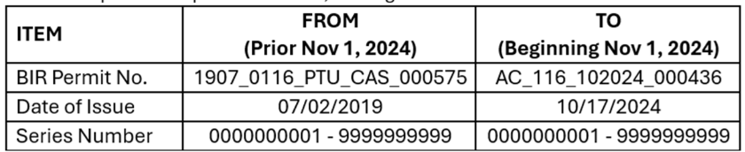
The requirement for Email and Print output are given below, however we will discuss on the Multiple emails and Print outputs.

- Billing Document email – As per MWC Requirement the Billing document must be sent to the Business partner through email, this may be sent in multiples meaning the First Email will not have any watermark, when the second third emails are sent to the customer, it should have the Watermark printed across the Billing document as “REPRINT” in next 2 additional printouts.
Note: Requested MWC for email content and as and when I get it, will provide the same.

Procedure

NA

Process Flow Diagram
NA

SAP Transaction
NA

Form Layout

Printer Requirements

The Printer Requirements will be shared shortly, meanwhile The Print Output has two Parts 1. Invoice going to the Customer/Bill to Party as an attachment 2. Print Outputs printed as a landscape having Water mark as specimens below the first one will have Re-Print and the second one will have Re-Print Receiving as shown below, this should be coming in one Sheet of A 4 Size as a Landscape, there should be clear demarcation of the two Documents as one document will be signed and sent back.

Example Printouts:

Legal Requirements
The Credit memo contains the VAT & TIN Numbers of both MWC & BP, Invoice Numbering will be given by the Government what needs to be printed at the Header under Credit memo. These are the statutory Requirements.

Form Fields

NA

Main Heading

NA

Sub Heading

NA

Totaling
NA

Sorting
NA

Page Breaks
NA

Stationery
When creating a print form for Credit memo in SAP, the choice of stationery is crucial for ensuring that the printed documents look professional and meet organizational branding standards.
Using plain A4 paper for SAP Billing print forms is a straightforward option that offers several advantages:
- Cost-Effectiveness: Plain A4 paper is generally less expensive than pre-printed options, making it a budget-friendly choice for organizations that process large volumes of purchase orders.
- Flexibility: This option allows for easy updates to the print form layout without needing to reprint or reorder stationery. Changes can be made directly in the SAP system, and new layouts can be printed as needed.
- Simplicity: For organizations that prioritize functionality over branding, using plain A4 paper can streamline processes and reduce complexity in managing different types of stationery.

Logo(s)

It is essential to ensure that all necessary logos are included in the emails and printed output. If pre-printed stationery is not used, we must provide a digital file containing each logo that needs to be incorporated into the print form. In MWC the logo will be dynamic and incorporated as per the Company code.



Bar Coding Requirements
NA

Email Requirements
When managing output types in SAP Credit Memo Output forms, it is essential to define specific requirements for email notifications. This includes the configuration of the email body, subject line, and other relevant parameters to ensure effective communication.
Below are the detailed specifications:
1. Email Subject: The subject line of the email should be concise yet informative. It typically includes key identifiers such as:
- Document Type (e.g., Billing)
- Document Number
- Business Partner Name or ID For example
2. Email Body: The body of the email should provide comprehensive details about the Sales/Service . Key components to include are:
- A greeting or salutation.
- A brief introduction stating the purpose of the email.
- Detailed information regarding the Billing include:
  - Billing Number/Statutory Government given Invoice Number
  - BP Information
  - Item Descriptions
  - Quantities and Prices
  - Delivery Dates

Existing Sample Forms
NA

Assumptions in Functional Design
NA

Open Issues in Functional Design
NA

Business Test Conditions

To ensure the successful operation of the form, a comprehensive testing strategy must be implemented. This includes various business level test conditions that cover functional, technical, and control scenarios.

Scenario # | Input Selection Criteria | Expected Result
1. | Use Transactional Fiori App from Fiori Apps Screen, Create Sales Order and Input Fields are ZCR/1100/10/10 and enter.  In the Sales Order Overview Scree, input Customer number in Sold To & Ship To Party Fields, add Customer Reference like PO.  Third step input material & Quantity and press Enter.  After Removing the Billing Block, SAVE. | Sales Order with all the Master Data elements like Payment terms, Inco terms, Weight and Volume will come into Sales Order with Pricing and Credit Memo will have a Billing block.  Credit Memo is created with the Credit Memo Number.  As you remove the Default Billing Block the Credit Memo Request is Saved.
2. | Use Transactional Fiori App Create Billing.  In the overview screen enter Credit Memo Request, Press Enter. | When you press enter all the sales related Pricing should come into the Billing document along with the Product/Services.
3. | Go to Header Texts, enter the Text you wanted to be printed in the Details of Credit Memo and Press Enter | You will be able to see the Credit Memo Text and language EN, this indicates that the Text is been taken.
4. | SAVE the Billing Document and use Transactional App Change Billing, and Go to Header Output | You should be able to see the output with the below Values.  1.Company Logo and Company Code Name with relevant address in Header section 2. Credit Memo Text with ODN Number is pulled from Reference Number in Billing Document 3. TIN Number and Government Identification Number pulled from BP Master Record 4. Text entered in the Credit Memo Text printed in the Description section of the Item/Service. 5. Acknowledgement details will be pulled from the Maintenance table into Invoice 6. Issued By and the respective MWC Entity Name should be appearing here.  This is the final result and if in all the steps the above result comes , it is deemed the Test is successful.

Related Documentation
NA

